Object Tracking

Kevin Andrade

Binghamton University

**Abstract**

This paper is centered on the PLS algorithm of object tracking and its benefits. The background of the algorithm and some related work is discussed. The PLS method is described and math is used to describe on how the algorithm analysis an image. The PLS algorithm, classified as a binary classification problem, determines what the foreground and background are. Different algorithms will be compared and tested through different visual scenarios to test their performance. The PLS algorithm is proposed to be used in various fields to simplify and improve them, such as the fields of medicine, surveillance, and the robotics. This paper shows how the PLS algorithm is used in those fields and the benefits that it provides to those fields. With the use of object tracking software, some ethical concerns arise, a philosophical view is used to address those concerns.

Object Tracking

**Introduction**

Object tracking software is on its way to being the new set of eyes for technology. Object tracking software can track and follow an object with its complex algorithms. Object tracking is implemented in various fields, and is used to improve the efficiency of human computing technology. There are many algorithms available in the field of object tracking, but some are better than others. The partial least squares algorithm (PLS), when compared to other algorithms such as the multiple instance learning algorithm (MIL) does a much better job at tracking objects in difficult visual scenarios, while improving the effectiveness of security and surveillance cameras, human-phone interaction, medical imaging, and traffic control. There are several factors that are taken into consideration when tracking objects in video, such as the quantity and shape of the object, and the visual scenario that the object is placed in. Philip et al. (2014) compares different algorithms against each other through a variety of experiments. Wang et al. (2012) further explains the handling of object analysis and tracking via the PLS algorithm; the authors also describe the issues of the PLS algorithm and its performance through a variety of experiments with different types of visual scenarios. Object tracking algorithms are a very popular research topic.

**Background**

Object tracking is a widely-studied topic, and is used in many fields, such as: the surveillance field, the medical field, and the robotics field (Wang, 2012). Object tracking gives an application the ability to track an object using complex algorithms; while object tracking has developed paths to improve different fields, there are some tracking algorithms that are superior to others. When in use, tracking algorithms depend on several factors, such as: the visual scenario, the prior knowledge about the object, and the number and shape of the object (Philip, 2014, p. 109). Normally, a tracking system is made from three parts: the evaluation model, which tries to evaluate where the object is, the appearance model, which attempts to guess where an object will be over time, and the search strategy, which finds the most likely location of the current image (Philip, 2014, p. 109). Tracking objects in high resolution video has been successful in the last 2 decades, but tracking objects in a low-resolution video has been challenging (Philip, 2014, p. 109). If an object moves fast relative to the frame rate of the video, then the image model is lost. Another complexity is when an object changes orientation over time, it makes it hard to track the dimensional shape of the object.

The ability to track human faces via surveillance cameras is essential to classify criminals. There are many criminals who escape crimes via cars, and it is difficult to track fast movement due to the occlusion handling, the motion blur, the change of appearance, and the change in illumination. Object tracking software is also used in military planes to track and lock onto enemies. Being able to analyze the human body via tracking algorithms is essential to the medical field; there are cases when a person must undergo surgery, and it is always a good idea to know the condition of the body before going into a medical procedure (Metaxas, 2005). The ability to track objects has revolutionized the industry, with the partial least squares algorithm being one of the superior algorithms.

**Precedents and Related Work**

Before object tracking algorithms were robust, there were different methods to track an object; people used software to go through a video frame by frame to track motion, this was long and tedious work. Object tracking has improved greatly over the recent years, with researchers and scientist creating and improving previous algorithms. There are numerous algorithms that will track objects at the click of a button versus the long and tedious way of going frame by frame to localize and track an object manually. Existing algorithms are categorized as either generative or discriminative methods (Wang, 2012, p. 4454). Generative methods track objects by searching the objects image and matching it with a template or appearance model in their database. Discriminative methods try to separate the object from its background. Despite the ease of newer tracking technologies, it isn’t always perfect. Real world object tracking is difficult due to the many visual changes happening throughout the tracking cycle. Sometimes, the object being tracked is partially hidden behind another object, and this causes a problem. Philip et al. (2014) compared multiple object tracking algorithms by putting them through various tests. He concluded that the PLS algorithm was overall the most accurate tracking algorithm when compared to other algorithms such as the MIL algorithm.

When dealing with occlusion handling, negligible motion, background clutter, and low contrast video, the PLS algorithm does much better job when compared to the MIL algorithm; the difference in the succession rate address the many social issues of inadequate object tracking.

There are hospitals that specialize in motion analysis, and every day, the need for stronger tracking software is desired (Connecticut Children’s office, 2017). The PLS algorithm aids the development of strong tracking software, which results in the improvement of medical practices. Hospitals can now track the posture and movement of joints with their video tracking software (Connecticut Children’s office, 2017), and are able to track internal organs to determine the patients’ health status (Metaxas, 2005), but the algorithms can still be improved. The results from Philip et al.’s tests concluded that the PLS algorithm was overall the best algorithm, but it still had complications keeping track of objects 100% of the time due to the difficult visual scenarios.

Real life cases such as traffic control, human and robot interaction, and medical imaging rely heavily on object tracking algorithms to track an object efficiently. War criminals can be tracked and identified via smart surveillance cameras which match their face via an online database, complicated organs can be studied and examined without having to go through surgery, and the government can have a more reliable system of tracking enemies from an aerial view via the PLS algorithm. Due to the mathematical nature of algorithms, some perform better than others.

**Support**

Despite the technical complexity of the PLS algorithm, the algorithm shows promise in advancements on different areas of society. The PLS algorithm performs in some incredible ways when put into test, and Wang et al. (2012) gives a technical analysis on how it happens.

**Object Representation**

Quing Wang, Feng Chen, Wenli Xu, and Ming Hsuan (2012) from Northwestern Polytechnical University, have an interest in computer vision, specifically object tracking. Wang et al. (2012) describes how the PLS algorithm works and how it can analyze and track images with superb tracking capabilities, even when the object being tracked is in a difficult visual scenario. Wang et al. state that the PLS algorithm is a statistical method that models the relations between sets of variables via latent quantities. Latent variables are variables that are not observed, but are rather inferred. A simple way to understand Object tracking is by viewing it as a classification problem as Wang et al. states. Object tracking distinguishes the background from foreground, with the PLS algorithm learning and processing low dimensional and discriminative feature subspace.

**Partial least squares analysis.** Wang et al. (2012) uses different types of dimensional space to describe the PLS analyses. The analysis phase of the algorithm works by correlating blocks of data together. The algorithm analysis the image, creates an m-dimensional space and an n-dimensional space where data is stored, then correlates the data together to determine the next movement of the object. PLS analysis is then modeled and correlated from object appearance to the classification of the object. The algorithm will attempt to detect and separate the background from foreground and match up the object with something within the database for object tracking algorithms. Wang et al. (2012) also states that the PLS algorithm creates multiple appearance models. If the object moves, the appearance of it will change; by creating various appearance models within the algorithm, it enables it to correlate back to the object that is being tracked without losing focus. The PLS algorithm rarely loses track of the object in which its tracking, making it a reliable algorithm to use in difficult object tracking situations.

**Experiments**

Rohito C. Philip, Sundaresh Ram, and Xin Gao (2014) from the University of Arizona conducted a few experiments with a variety of cases with difficult visual scenarios and compared them to other algorithms. The experiments mimicked many real-life cases when tracking an object, such as: occlusion handling, partial object occlusion (having an object be partially hidden), background clutter, and many more. Philip et al. states that it becomes difficult to track small objects in a lower resolution video, but the PLS system seems to perform the best overall when compared to other algorithms such as the MIL algorithm. Tracking small objects depends on several factors as mentioned previously, such as: the quantity and shape, and the prior model knowledge of the object. The experiments conducted were shot from an aerial view with a video resolution of 720 x 480p, with approximately 39 cars going across all 50 frames. Overall, the PLS algorithm achieved better results when compared to the other algorithms.

**Overall accuracy.** Six algorithms were tested against each other. Philip et al. measured accuracy based on two metrics, localization error (the error in localizing the correct object) and overlap accuracy (when another object gets in front of targeted object). The PLS algorithm performed the best overall when compared to other algorithms. Other algorithms are comparable in their overlap accuracy percentage, excluding the MIL algorithm being last in the list as seen on figure one.

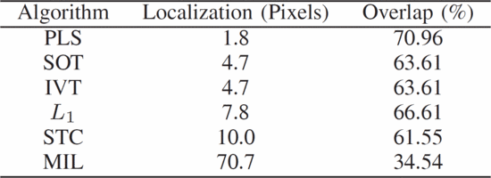

*Figure 1.* Performance metrics. (Philip, 2014, p. 110).

**Occlusion handling.** While the test was being conducted, car number 36 was a big challenge for the tracking algorithms (Philip, 2014, p. 111). Between frames 18-27 car number 36 was partially hidden behind a traffic light. Again, the PLS algorithm performed with amazing accuracy and tracked all 50 frames. Although, almost half of the algorithms that were tested failed to track the object when it went behind the traffic light, they managed to track the object from 11 frames and under as seen in figure two.

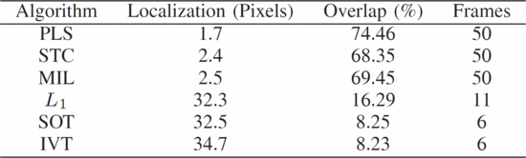

*Figure 2.* Occlusion Handling Performance metrics. (Philip, 2014, p. 111).

**Background clutter.** Car 10 is the object being tracked for this test with many cars going at different speeds along car 10’s side, and some stationary (Philip, 2014, p. 111). Normally, tracking an object that is stationary proposes a problem for algorithms because tracking algorithms are made to track moving objects. Despite the difficulty, the PLS algorithm performs the best by tracking the car through all 50 frames. The MIL algorithm is last in the list by only tracking two frames. On figure three, the graphs show on how the PLS algorithm performs by keeping a more stable percentage of tracking an object while there are other objects in the scene. Figure three-part b also shows how small the pixel error is of the PLS algorithm, the higher number of pixels means a higher error of localization of the object.

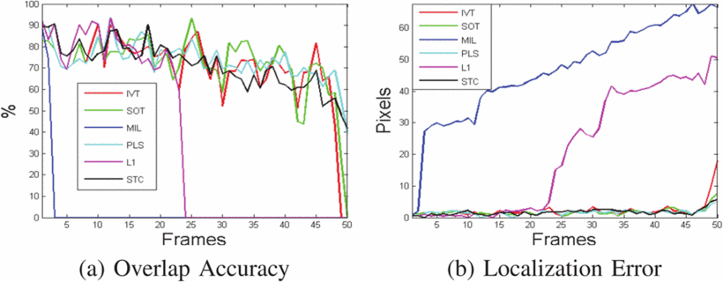

*Figure 3.* Background Clutter. (Philip, 2014, p. 111).

**Low contrast.** Tracking an object is difficult when the color between the object and its surroundings looks the same (Philip, 2014, p. 112). Philip et al. states that if there is little contrast between the background and the object, then the tracker might become confused. Despite the potential issues, the PLS algorithm performs extraordinary by tracking all 50 frames of a car that are similar in color as the ground. The PLS algorithm performs well in real life scenarios with many benefits to the world. Figure four shows the PLS algorithm placing second in tracking objects in low contrast scenarios, being beat with a 0.3 score difference by the L1 algorithm.

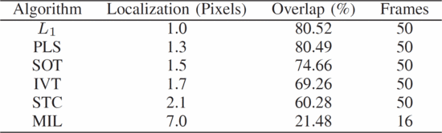

*Figure 4.* Low Contrast Performance metrics. (Philip, 2014, p. 112).

**Implementation**

Some jobs place a great amount of stress on an individual. Francisco Cuellar and Alexander Lopez (2017), graduates from Pontifica University in Peru, state that there has been an increase of demand in robotic workers. Many fields acquire robots to aid human work. The field of security services is growing, and some countries do not have enough trained personnel to do the job. Security services is an exhausting job, and experts are aiding the security field with robotic workers. Cuellar and Lopez (2017) state that the robotic workers do nightly patrols, and during the day they welcome and provide information to customers. Figure five shows the grand showing of the security and greeter robot.

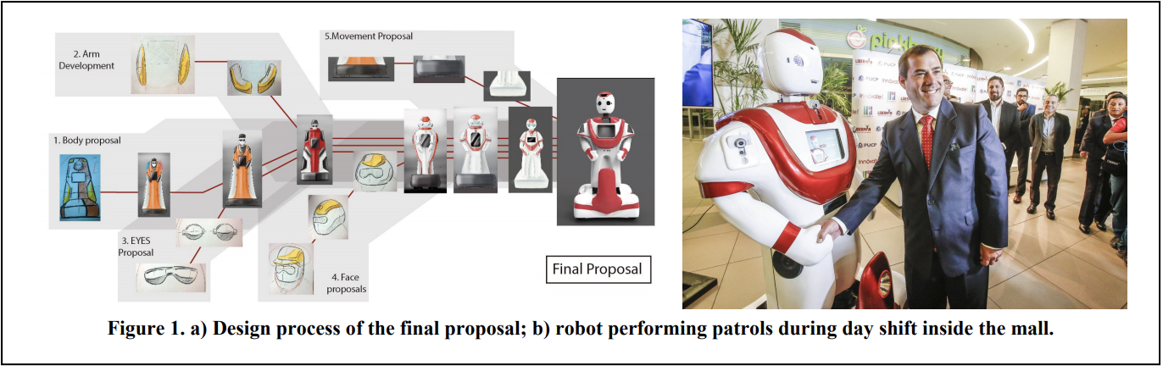

*Figure 5.* Robotic Greeting and Implementation. (Cuellar and Lopez, 2017, p. 410)

The robot is filled with multiple camera sensors to be able to drive around with its implanted wheels. For the robot to navigate itself around during the night, it is important to have a robust object tracking software installed, aiding the development of humans and society.

**Social Impacts and Ethics**

The PLS algorithm performed great during the tests performed by Philip et al.; with the continued advancements of modern technology, object tracking simplifies many tedious and hard tasks with object tracking algorithms. The medical field and robotics field benefit greatly from a robust software that can track an object. Dimitris Metaxas (2005) talks about the importance of image modeling and analysis to the medical field. Metaxas (2005) is the director of the Computational Biomedicine, Imaging and Modeling Center and is the curriculum chair of computer science at Rutgers School of Arts and Sciences. Metaxas describes the importance of organ image analysis. Doctors, can now analyze and inspect an organ without having to do any surgeries. The advancements of the PLS algorithm help track low contrast objects, which aids to the tracking of patient’s organs due to lack of contrast. With the help of object tracking algorithms and modeling, new 3D structures can be made from a patient’s organs to further and better examine. The robotic field is also advancing at a rapid rate. Woo-Han Yun, Young-Jo Cho, Dohyung Kim, Jaeyeon Lee, Hosub Yoon, and Jeohong Kim are from China with a computer engineering degree. Yun et al. states that object tracking requires a lot of computational power, but they come up with a solution to make a portable moving robot with face recognition software on board. They modified an object tracking algorithm to work on the robot which tracked people’s faces. Giving robots the capability to track and recognize human faces and features revolutionizes the world. This ability grants the ease of a robot to potentially track and hold a conversation with a human. Object tracking algorithms are a great and robust tool for humanity

The benefits of the PLS object tracking algorithm benefit most of humanity, but one might ask whether it is okay for the government to use this type of technology to target enemies and take their lives away. Kim Todd, Tabatha Verbick, and Merlin Miller (2001) graduates from Northwest Missouri State University bring up the question if Universities should teach computing ethics to students. Todd et al. (2001) states that the U.S is behind in teaching computing ethics when compared to other countries. As a comparison of ethical teachings, Netherlands has had ethics implanted in their curriculums since 1944. Although one might argue that ethics is based on cultural values, one could also say that there are global values. Todd et al. (2001) brings up a point on which everyone agrees with certain ethical decisions. If someone wanted to hack into a person’s email, this would be considered ethically wrong and the majority would agree. Ethics also comes into question when the government decides to watch someone through their smart surveillance cameras and hope they catch a criminal by tracking the persons face and matching it with a database. Despite these concerns, the majority would benefit from tracking algorithms if the situation is viewed from the utilitarianism view. As explained in chapter one in the Gift of Fire by Sarah Baase (2013), the utilitarianism view sees who will benefit the most from a certain action or decision. If the situation is seen from the point of view of safety, algorithms such as the PLS method, will benefit people the most by being able to track faces through surveillance cameras and resulting in a criminal arrest. Being able to track human organs to study and analyze them before surgery, and helping the government track on to enemies and eliminating them is a great advancement in civilization. The PLS algorithm helps to make robust tracking software which benefits many people. If the situation of ethics was viewed from the deontological view, where it is viewed the “rightness of actions”, then it would not be the most appropriate view. The deontological view is upheld by moral rights, a person cannot do anything that is morally wrong. Morality is a tough subject, and when morality and the death of terrorist are put together, it makes it tough to have any progression in society. If the actions actions of object tracking are viewed with the point of view of morality, then cases like catching criminals would never happen because of the invasion of privacy.

**Conclusion**

There are many benefits to being able to track an object. The PLS algorithm performed great in tracking objects, even when there were obstacles such as the occlusion handling, background clutter, and low contrast. Object tracking also improves the effectiveness of surveillance cameras, medical imaging, and human and technology interactions. Improving the effectiveness of surveillance cameras results in easier monetarization, resulting in ticketing and the reduction of unsafe drivers. Object tracking is also helping the medical field rapidly improve and be more efficient. Hospitals such as the Connecticut Children’s Medical Center use motion tracking to aid their examinations. The hospital uses motion analysis to track joint movement to ensure the correct motion is being performed when patients are rehabilitating (Connecticut Children’s Office, 2017). Other medical offices track internal organs to study and analyze them, this prevents unwanted injuries (Metaxas, 2005). Human and robotic communication is also advancing, with modified versions of tracking algorithms, it is seen that robots can now track a human’s face (Yun et al., 2013). Franciso Cuellar (2017) states that the market of robotics is rapidly growing; some malls are implementing robots in their security department to perform nightly patrols. In the book of fire by Sarah Base (2013) the concern of technology taking over humans is mentioned. Cuellar (2017) answers this question by stating that the aim of robotic technology is not to replace humans, but to improve and help the daily life of humans. Object tracking algorithms can be implemented into different areas of technology. Object tracking technologies would fail to do its task without object tracking algorithms. Cuellar (2017) mentions that robots have various types of sensors, and most of them are to track objects; Philip et al. (2014) also shows how vital the PLS algorithm is when doing surveillance. The aid of object tracking technology will boost the efficiency of human civilization by aiding humans in task intensive jobs.

**References**

Alexander, J, L., & Cuellar, F. (2017, March). *ROBOTMAN: Security Robot for Human-robot Interaction Inside Malls.* Proceedings of the Companion of the 2017 ACM/IEEE International Conference on Human-Robot Interaction, New York, NY, 410. doi: 10.1145/3029798.3036653

Alexander, J, L., & Cuellar, F. (2017). Robotic Greeting and Implementation. Retrieved from https://dl.acm.org/citation.cfm?id=3036653

Baase, S. (2013). *Gift of fire: social, legal, and ethical issues for computing technology*. 4th Edition. NY, NY: Pearson.

Connecticut Children’s Office. (2017). *About motion analysis*. Retrieved from https://www.connecticutchildrens.org/orthopedics-center-for-motion-analysis/what-is- motion-analysis/

Metaxas, D. N. (February 2005). Introduction. *Communications of the ACM*, *48*, 26-29. doi: [10.1145/1042091.1042115](http://dx.doi.org.proxy.binghamton.edu/10.1145/1042091.1042115)

Philip, R. C., Ram, S., Gao, X., & Rodriguez, J. J. (2014, April). *A comparison of tracking algorithm performance for objects in wide area imagery.* 2014 Southwest Symposium on Image Analysis and Interpretation, San Diego, California, 109-112.USA. doi:[10.1109/SSIAI.2014.6806041](https://doi.org/10.1109/SSIAI.2014.6806041)

Philip, R. C., Ram, S., Gao, X., & Rodriguez, J. J. (2014). Performance metrics. Retrieved from http://ieeexplore.ieee.org.proxy.binghamton.edu/document/6806041/

Philip, R. C., Ram, S., Gao, X., & Rodriguez, J. J. (2014). Occlusion Handling Performance

metrics. Retrieved from http://ieeexplore.ieee.org.proxy.binghamton.edu/document/6806041/

Philip, R. C., Ram, S., Gao, X., & Rodriguez, J. J. (2014). Background Clutter. Retrieved from http://ieeexplore.ieee.org.proxy.binghamton.edu/document/6806041/

Philip, R. C., Ram, S., Gao, X., & Rodriguez, J. J. (2014). Low Contrast Performance metrics. Retrieved from http://ieeexplore.ieee.org.proxy.binghamton.edu/document/6806041/

Todd, K., Verbick, T., & Miller, M (2001, October).  *Ethics education in the microchip millennium.* SIGUCCS ACM Special Interest Group on University and College Computing Services, New York, NY, 271 – 273. doi: 10.1145/500956.501028

Wang, Q., Chen, F., Xu, W., & Yang, M. (June 2012). Object tracking via partial least squares analysis*. IEEE Transactions on Image Processin*g, *21*, 4454-4465. doi: 10.1109/TIP.2012.2205700

Yun, W., Cho, Y., Kim, D., Lee, J., Yoon, Hosub., & Kim, J. (2013, August). *Robotic person- tracking with modified multiple instance learning*. 2013 IEEE RO- MAN, Gyeongju, South Korea,198-203. doi:10.1109/ROMAN.2013.6628445